Progress Report

Grant U54 HG004028

The National Center for Biomedical Ontology

CORE 4
May 6, 2006

Specific Aims
The specific aims for Core 4, Infrastructure, are:

- We will create and administer archival storage systems to support the BioPortal.
- We will create online resources for access to the Center’s software.
- We will provide technical support to assist users of the Center’s services.
- We will provide collaboration tools to link all the investigators participating in the Center.

Studies and Results

Aim 1: We will create and administer archival storage systems to support the BioPortal
In our first year, we have purchased and installed our file servers and databases at Stanford. We created an architecture of 4 servers: a staging and production Web and Application server (Table 1) and a staging and production database server (Table 2). Both database servers are running Oracle 10g relational database system. We also reconfigured and deployed a fifth server to serve as a development platform. Each site in our Center also set up their own local servers for individual research.

Table 1: Production & staging Web/application server configuration (Dell PowerEdge 2850)

Base Unit: | 3.2GHz/2MB Cache, Xeon, 800MHzFront Side Bus for PowerEdge 2850 (221-7956)
Processor: | 3.2GHz/2MB Cache, Xeon, 800MHzFront Side Bus, 2nd processor for PowerEdge 2850 (311-4846)
Memory: | 4GB DDR2 400MHz (2X2GB), Dual Ranked DIMMs (311-3593)
Hard Drive: | 146GB,U320,SCSI,1IN 10K,PE2850 (341-1306)
Hard Drive Controller: | Embedded RAID - PERC4 Embedded Integrated (341-1506)
Additional Storage Products: | 146GB,U320,SCSI,1IN 10K,PE2850 (341-1306)
Operating system | Debian 3.1 Linux

Table 2: Production & staging Database server configuration (Dell PowerEdge 2850):
Base Unit: | Dual Core, 2.8GHz/2x2MB Cache Xeon 800MHz FSB for PowerEdge 2850 (222-0209)
Processor: | Dual Core, 2.8GHz/2x2MB Cache Xeon 800MHz FSB, 2nd processorfor PowerEdge 2850 (311-5402)
Memory: | 12GB DDR2 400MHz (6X2GB) Single Ranked DIMMs (311-3607)
Hard Drive: | 146GB,U320,SCSI,1IN 10K,PE2850 (341-1306)
Hard Drive Controller: | Embedded RAID - PERC4 Embedded Integrated (341-1506)
Additional Storage Products: | 146GB,U320,SCSI,1IN 10K,PE2850 (341-1306)
Feature | MR1R10, ROMB RAID 1/RAID 10 Drives attached to PERC4ei PE2850 (341-1365)
Operating system | RedHat 4 Enterprise Linux

The Ontologies in the Open Biomedical Ontologies (OBO) library, as well as all legacy ontologies and terminologies available to the Center, will be accessed via the LexGrid middleware described in Section 1.D.5.1. LexGrid itself uses the Lightweight Directory Access Protocol (LDAP) to store ontologies and terminologies in an extremely efficient manner. We therefore will be installing LexGrid and LDAP on the Stanford server as well.
Maintenance of the Stanford servers will be performed by members of the School of Medicine’s Information Resources and Technology (IRT) group, who have an agreement with Stanford Medical Informatics to provide support for all our servers, to backup those servers to tape on a daily basis, and to troubleshoot and repair any problems as they may arise. As a result, there are no direct personnel costs for server maintenance that will be charged to this grant.

The Bioportal is a built on a three tier architecture comprising of Apache Webserver(version 2), Jboss application server(version 4.0.4) and Oracle database server(version 10g). All the technologies are Java based. Some of the software technologies include ejb3 with hibernate as the persistence manager, which gives the ability and flexibility to host both remote and local object access. SOAP services which enables other applications to use our software components. JMS is used to support messaging and background processing services. ADF Faces which is built on Java server faces technology is used as our User Interface framework is component based for building reusable and powerful user interface. It also has AJAX like features which makes the User Interface faster.

The other integrated components are API’s that are provided by various other groups. PROMPT is a Java Based API used for ontology alignment. Lexgrid services are used for Parsing and Indexing ontologies into the database. It uses pure jdbc to convert file based data to a relational model. Lucene indexing is used to enable search across and within an ontology. The lexgrid API also enables to query part or all of the ontology and relationships and enable various visualization techniques for the ontology.

After reviewing our options for server hosting support, we decided to use the Stanford ITS hosting services instead of IRT, because ITS provides services with great competence in a very timely manner for data-intensive projects throughout Stanford Medical Center. ITS is currently hosting mission-critical IT applications for the hospital as well as for Highwire Press. They also have a robust and physically-secure Data Center, and they provide high speed networking, a secure firewall, uninterruptible power supply, climate control, computer racks, system monitoring, remote console, and backup and recovery, upgrade and patch of hardware and software. They provide various DBA services make sure our database is supported 24*7. They also provide monitoring services on the application server as well as the web server.

All research staff associated with the Center have received training in HIPAA and the protection of patient privacy.

Aim 2: We will create online resources for access to the Center’s software
A major function of the Center will be to enable access to ontologies, metadata, experimental data, and data annotations, as outlined in our discussion of Core 1 and Core 2 in our progress report. Our BioPortal will be the central applications-oriented infrastructure that our Center is developing.

Since initiating our Center, we have been promoting the dissemination of self-contained software tools that are useful to the biomedical community. These tools include:

- Tools for editing ontologies, such as Protégé and OBO-Edit
- Tools for visualizing ontologies, such as JAMBALAYA
- Tools for adding metadata to ontologies (such as peer-review tools; Core 1)
- Tools for visualizing ontology-based metadata used to annotate experimental data sets (Knowledge Zone; see report for Core 1)

We created a Web site for the Center (http://bioontology.org) which will provide a one-stop site to access the Center’s content. Currently, users access tools such as Protégé and OBO-Edit directly from their source Web sites, but we will soon integrate access to these tools into the Center’s Web site to enhance their dissemination.

Aim 3: We will provide technical support to assist users of the Center’s services
We created e-mail distribution lists and online message boards to enable users to obtain technical support and to facilitate communication among Center members. (See Figure 1). We also created a cBIO-help mailing list to enable users to pose questions privately to the Center’s technical staff (info@ncbo.us) as well as an email list for potential collaborators to contact the Center with inquiries related to the collaborative NIH programs (collaborations@ncbo.us).

Our discussion mailing lists have enabled general questions to be posed publicly, so that all users in the community can see the questions, learn from the responses, and potentially offer advice of their own.

We have adopted the Stanford mailman email lists service to manage our distribution lists. This service enables us to add new lists and to easily change list memberships, giving us the flexibility to handle the changing needs for communication among Center members on issues related the Center’s resources, software, and administration.

We have begun to work closely with the user community as our Center evolves to identify user needs and to respond with appropriate support mechanisms. We regularly monitor the OBO-discussion lists and participate in teleconference calls for groups interested in biomedical ontology, such as the Biomedical Information Research Network (BIRN) Ontology Task Force (OTF), the W3C Semantic Web for Life Sciences BioRDF group, and the caBIG Imaging Workspace Vocabulary and Common Data Elements (VCDE) working group.

While our Center has only recently begun its work, we have had many questions from our user community related to using Protégé, OBO-Edit, and ontologies. We have been actively supporting them via our Protégé email discussion lists and Open Biomedical Ontologies (OBO) list. It is our commitment is to ensure that users of our Center’s resources will obtain the same high level of satisfaction as that enjoyed by the current community of Protégé users.

Aim 4: We will provide collaboration tools to link all the investigators participating in the Center
Our Center comprises several performance sites and is currently supporting three driving biological projects at outside institutions. We installed Wiki technology to support collaboration and communication among all the Center’s participating groups. Our Center’s Wiki (Figure 1; http://smi.stanford.edu/projects/cbio/mwiki-internal/index.php/Main_Page) is currently the primary mechanism for communication among Center members. It contains sections for current news, action items, agendas and minutes from meetings, list of meetings and events, and a developer area for technical documents. There is also a dissemination wiki within the main wiki containing material related to the dissemination workshops led by Dr. Smith. The materials from those workshops and presentation slides are available for download. The wiki also contains a repository of shared documents and slides, as well as an area for tracking potential collaborations with the Center.

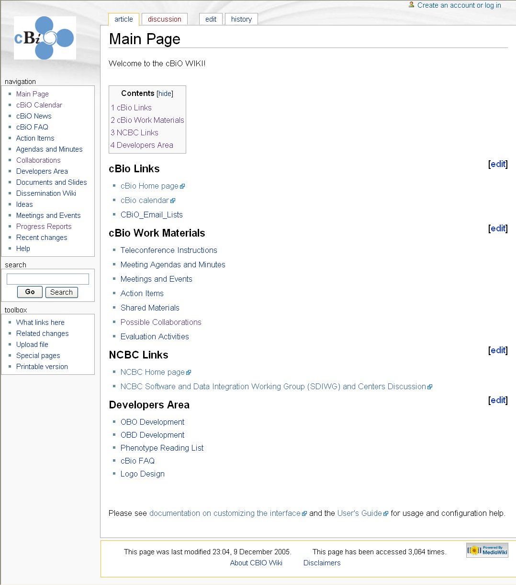
Figure 1. The Center’s Wiki provides a one-stop Web site to access shared materials for the Center, as well as serving as a public place for the biomedical community to learn more about the Center’s work and access learning resources such as slide presentations.

We also established a CBiO calendar (Figure 2), accessible to all our colleagues on the Internet.

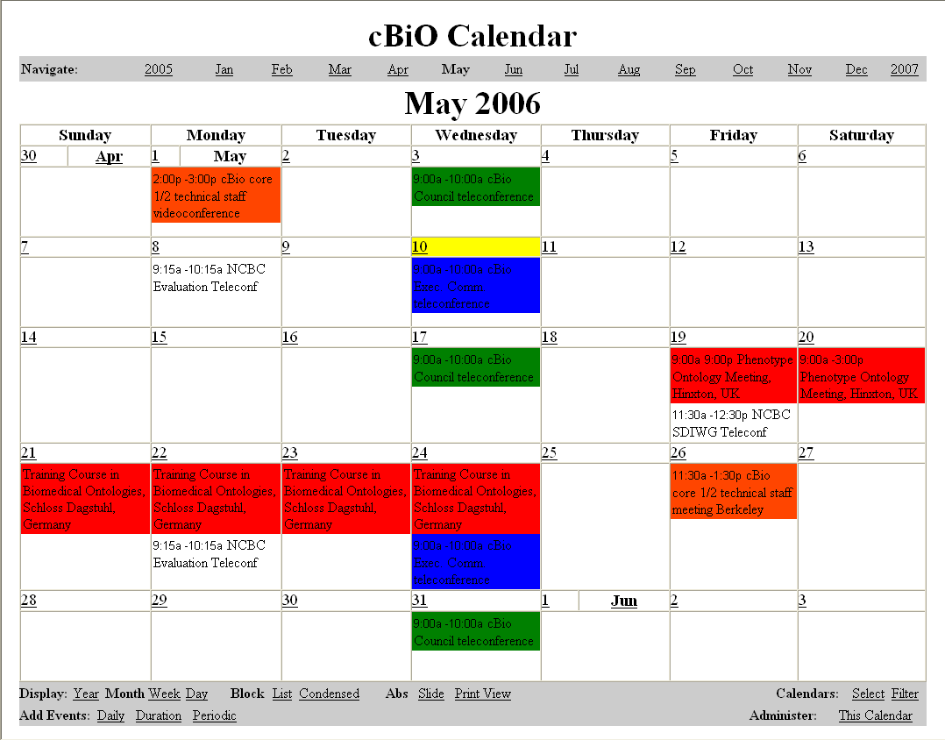
Figure 2. The CBiO calendar maintains the schedule of current events, meetings, and other important dates for the Center.

As soon as our Center began, we initiated and have been continuing bi-weekly teleconferences, alternating between the Executive Committee and the CBiO Council. On the Executive Committee calls, issues related to the mission of the Center are discussed and strategic decisions are made. On the CBiO Council calls, the status and progress of activities occurring in all cores are discussed. Issues requiring Center review and decision are taken up on the Executive Committee calls.

We have also bee scheduling ad-hoc teleconference and video conference calls with individual centers as needed to identify synergies and enable their work. For example, we have had regular video conference calls with University of Victoria to stay abreast of their visual interface prototyping work and anticipate how their efforts to create ontology visualization and data visualization services will be deployed in BioPortal.

Significance
Our robust infrastructure is critical to supporting our community of biomedical researchers who will be accessing BioPortal. We have established a hardware platform that we will believe will serve our Center well for the next few years. At the same time, our infrastructure can grow to meet the growing needs of biomedical researchers. An important functional requirement of our infrastructure is to support the dissemination and communication mission of the Center. We have established the servers and services needed to support our users needs. We believe our Web site and Wiki will be particularly helpful in enabling our users to interact with the Center and its staff.

Plans

1. We will create Web-based facilities, such as the one currently developed for the Protégé resource (http://protege.stanford.edu), that will enable users to download the Center’s software and to install the programs locally.

2. We will store on the Stanford server all end-user documentation and user-support materials.

3. We will enhance our Center’s Web site to include access to discussions forums and email lists to facilitate communication between users and the Center.

