Progress Report

Grant U54 HG004028

The National Center for Biomedical Ontology
May 6, 2006

Specific Aims
The specific aims for Core 1, computer science, are:

- Develop a resource for long-term management and integration of ontologies, the Open Biomedical Ontologies (OBO).
- Create BioPortal, a Web-based system to provide human users and intelligent agents access to a virtual library of the relevant ontologies.
- Develop facilities for defining and accessing mappings among ontologies and terminologies.
- Develop the technology to support a web of trust to enable the scientific community to apply peer-review methods to ontologies and their associated data.
- Develop tools to create and use metadata for indexing, accessing, and categorizing ontologies.
- Develop methods and tools to visualize ontology libraries and their contents

Studies and Results
In this report, we describe or progress on the first 3 aims of our research and development activities. Work on aim 4 has not been begun, and progress on Aims 5 and 6 are reported in the Mayo and UVIC progress reports, respectively.

Aim 1: Develop a resource for long-term management and integration of ontologies, the Open Biomedical Ontologies (OBO)
We created an initial software architecture for the OBO library of ontologies. We first developed a functional specification for entire project by gathering functional requirements and translating high level project goals into definable entities. We selected a technology stack (application server, UI components, statistics software, etc.) after extensive research into alternative choices that would meet our functional requirements. We also investigated the new Center resources available to us, such as LexGrid, Protégé, and OBO Edit in order to understand how best to integrate these technologies into our software architecture for OBO and BioPortal. We finalized our architecture design (see Error: Reference source not found).

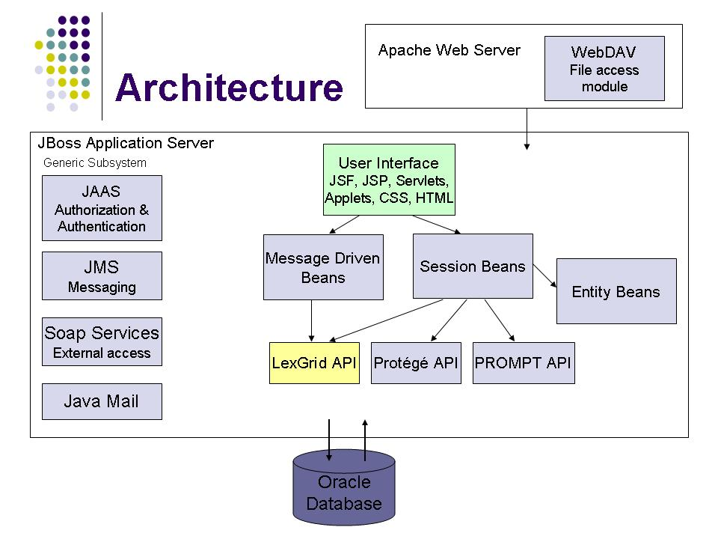
Figure 1. Software architecture for OBO. Submitted ontologies will be stored in an Oracle database which will support LexGrid API functionality. The user interface to OBO will receive content via Java beans and APIs to LexGrid, Protégé, and PROMPT. JBoss will provide our application server functionality.

In order to implement the architecture shown in Error: Reference source not found, we developed a project plan, and we set up a subversion repository and bug tracking database. We created build scripts to automate the software build process. We also defined machine requirements, such as testing, production, and configuration to establish our development and production hardware configuration. We also defined and implemented the Information Technology infrastructure to ensure BioPortal housed in data center, with backup and data recovery procedures.

We defined the functional requirements for the OBO resource, building on the current functionality provided by obo.sourceforge.net. We developed a migration plan, wherein the current ontology versioning repository functionality of obo.sourceforge.net would be retained, but the OBO library functionality would be provided by our new OBO resource.

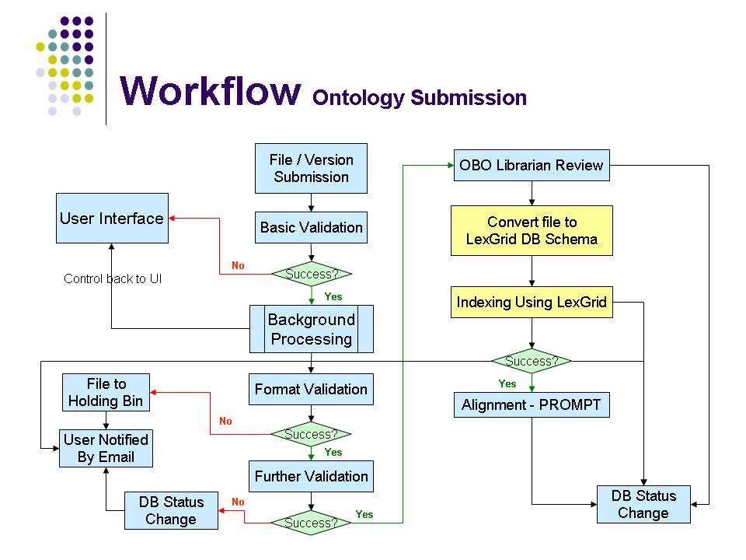
Figure 2. Workflow pipeline for ontology submission. Ontologies submitted via the BioPortal to OBO will undergo a tiered set of validations, ultimately leading to review by an OBO Librarian. Subsequently, the ontology content will be incorporated into OBO and used to drive the breadth of OBO ontology services such as format conversion, indexing, and alignment.

Aim 2: Create BioPortal, a Web-based system to provide human users and intelligent agents access to a virtual library of the relevant ontologies
We designed the server and user interface architecture for BioPortal, including an ontology submission pipeline (Error: Reference source not found). The pipeline begins when a user submits an ontology. Basic validations on the submission are conducted, such as format validation, ultimately leading to OBO Librarian review and storage in OBO. The pipeline includes the key functionality of OBO, including format conversion, indexing by LexGrid services, and ontology alignment.

We also implemented the following functionality:
- Infrastructure logging, exception handling design
- Authorization and authentication registration, sign in/out, account maintenance, password encryption, pluggable user storage model, page and functional access restriction
- Ontology metadata create, edit, details, download in XML
- Ontology library list, details, submit new, download, submit version, edit version

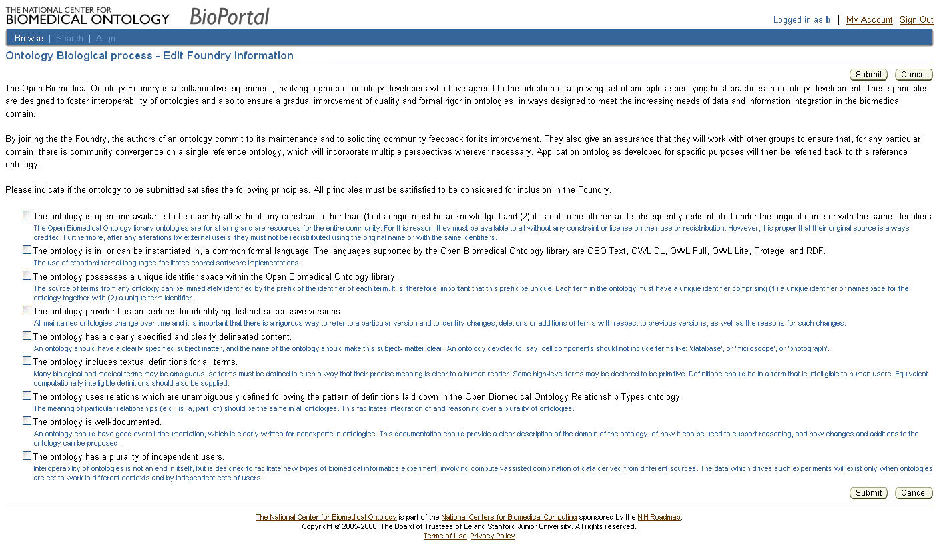
Figure 3. OBO Foundry criteria form in BioPortal. We have implemented the OBO Foundry criteria as a data entry form in BIoPortal allowing users to specify whether their ontology meets the criteria to be include in the OBO Foundry of ontologies in OBO. The designations provided are subsequently added as ontology metadata associated with the ontology stored in OBO, and submitted to be reviewed by the OBO librarian as part of the ontology processing pipeline in BioPortal (Figure 2).

In addition to the above functionality, we also implemented the OBO Foundry criteria in BioPortal as a set of metadata collected for the submitted ontologies (Error: Reference source not found). The OBO Foundry is an effort in ontology collaboration, involving a group of ontology developers who have agreed in advance to the adoption of a growing set of principles specifying best practices in ontology development.

We have created a working prototype of the BioPortal (Error: Reference source not found). In this first version of BioPortal, the OBO ontology library is presented as a tree view, with individual ontologies categorized by category of ontology. Users can expand different branches of the tree to view specific ontologies. Ontologies can be downloaded, and metadata describing the ontologies can be displayed.
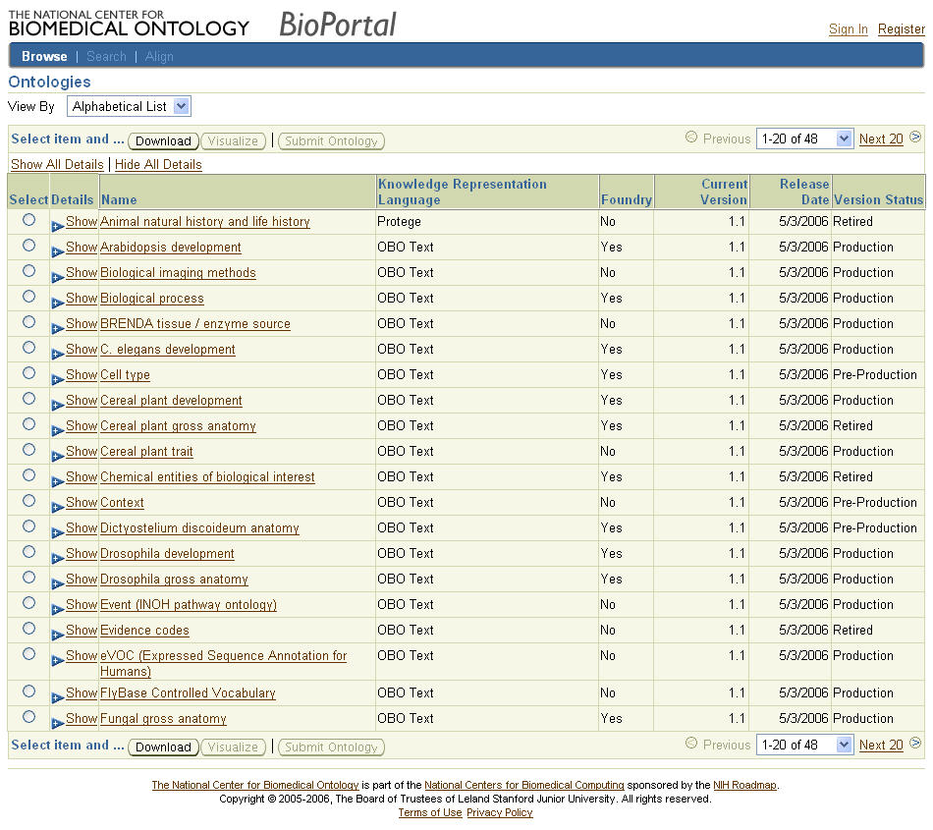
Figure 4. BioPortal working prototype. This screen shot shows the library of ontology, displayed as an expandable list of ontology categories, such as biological processes, cell types, and anatomy. Users can expand the tree of ontologies (), download them, and view metadata associated with them.

The tree display of ontology content is helpful because OBO will contain many ontologies. Even in the current OBO library, this display can help users navigate and view the number of ontologies in user-friendly manner (Error: Reference source not found). The BioPortal currently displays the type of ontology, its name, the file type for the ontology, whether it is part of OBO Foundry, the current version number, release data, and its status (Error: Reference source not found).

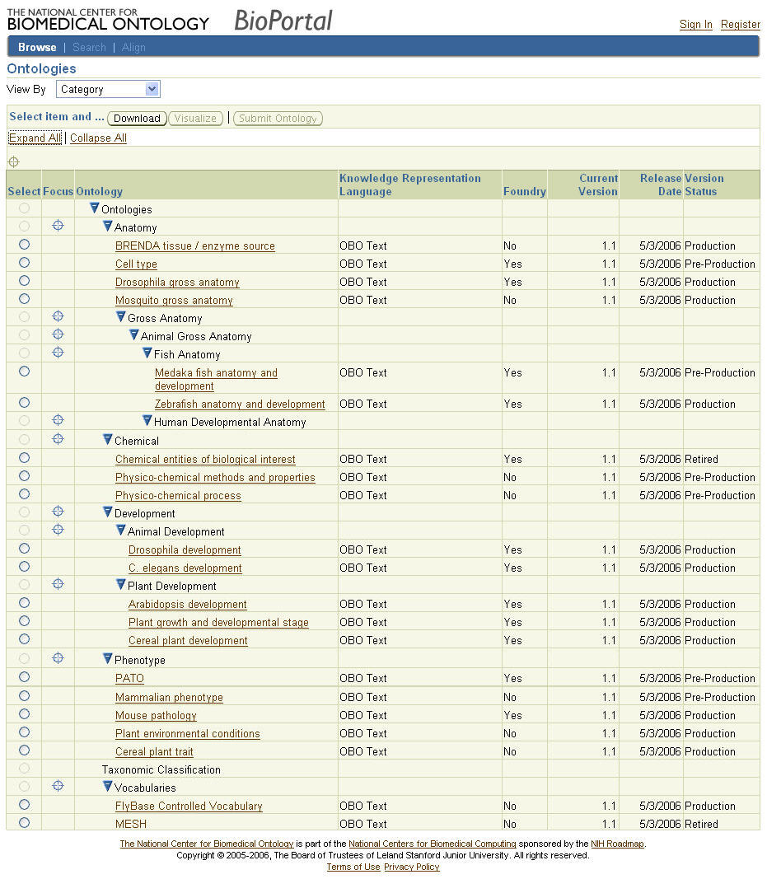
Figure 5. BioPortal screen shot showing expanded list of ontologies. Users can view the individual ontologies contained in OBO by navigating an ontology of ontologies, view their metadata, and download them.

Aim 3: Develop facilities for defining and accessing mappings among ontologies and terminologies
We have been collaborating with the Protégé group at Stanford as well as our University of Victoria colleagues to determine alternative strategies for ontology alignment and visualization of those alignments. We evaluated use of the PROMPT plug-in for Protégé to provide the alignment functionality, and we determined that adopting PROMPT to work within the BioPortal architecture would be the best initial strategy.

We have also developed methods to automatically map ontologies based on annotations on biomedical data. Data that is annotated with terms from multiple ontologies provides evidence that can be used to align ontologies. To demonstrate the applicability of this method, we mapped approximately 80% of annotations for the samples in the Stanford Tissue Microarray Database to ontology terms. We found that a significant proportion of the diagnosis-related annotations map to terms from both the NCI thesaurus and SNOMED-CT. This mapping of a single record to terms from different ontologies presents a concrete data-driven mechanism for aligning related ontologies by using them for annotation. Such data-driven alignments have the potential to be complementary to existing alignment approaches, such as PROMPT, and may be used in tandem to better align related ontologies.

Aim 4: Develop the technology to support a web of trust to enable the scientific community to apply peer-review methods to ontologies and their associated data
We have implemented an initial version of a Web-based resource to collect ontology metadata from the community, called KnowledgeZone. This resource permits users to describe ontologies in terms of metadata, and to rate ontologies in qualitative manner.

Aim 5: Develop tools to create and use metadata for indexing, accessing, and categorizing ontologies
In addition to the results we describe here on pictorial-guided browsing of ontologies, please also see separate progress report from Mayo which describes creation of the LexGrid platform which will enable us to index and access ontology content.

We created a Pictorial Ontology Navigator (PON) in collaboration with our UVIC colleagues to enable users to use images of biomedical structures to guide the navigation of ontologies. PON was built in JAVA, and it enables users to browse annotation data associated with ontologies (Error: Reference source not found).

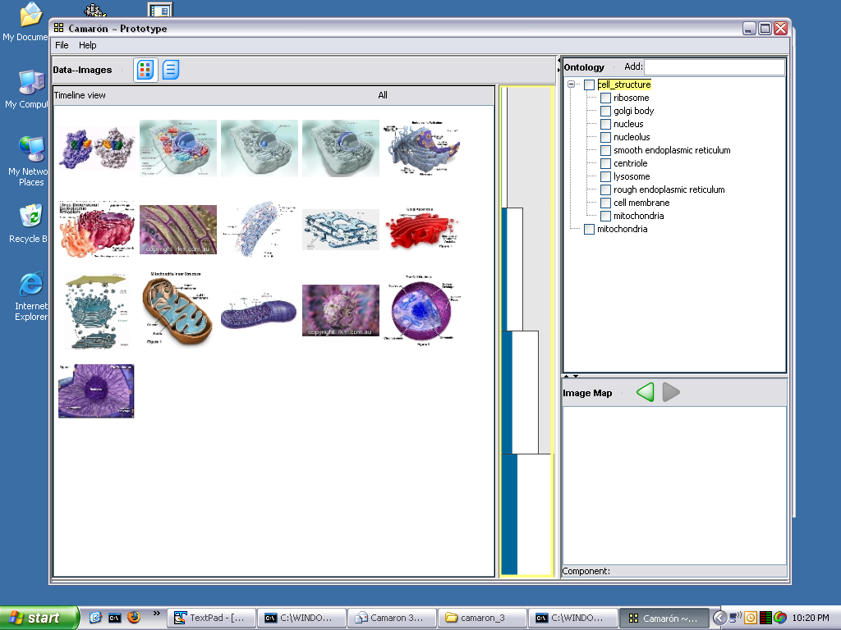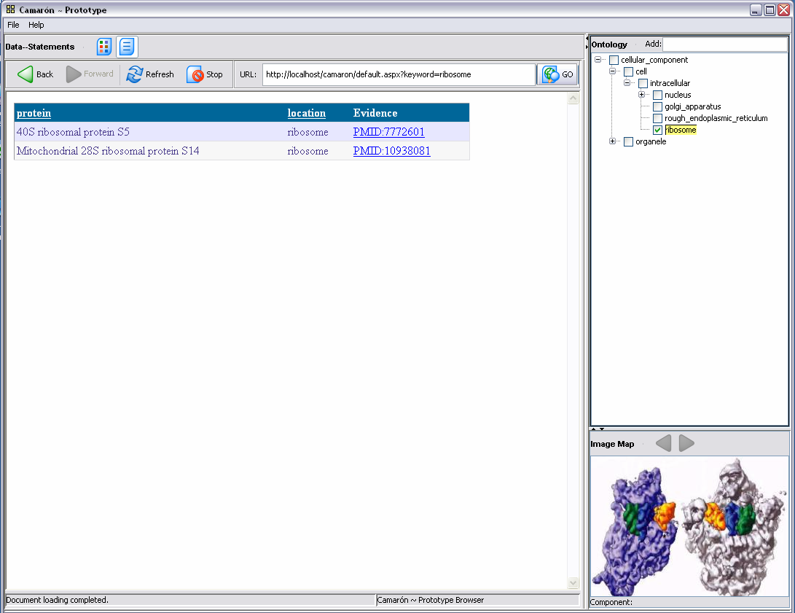
Figure 6. Pictorial-guided navigation of ontologies. Figure on the left illustrates a library of images at different anatomic scale, ranging from macroscopic to microscopic components. The user can select an anatomic scale (left panel in figure on left), which will restrict the granularity of ontology classes displayed (right panel in figure on left). Once a user selects an anatomic scale, they can navigate to sub-scale components, simultaneously restricting the ontology granularity (figure on the right).

The PON tool can import jpeg, bitmap and gif file formats. The images are segmented to demarcate regions of anatomic structure, and the segmentation information is stored as image maps that are converted into a table via a script. This table is loaded into the mysql database that the PON uses. The ontology that PON enables users to navigate is accessed by the application.

Clicking on an ontology term retrieves the image associated with that ontology term and loads the image map for that image (Error: Reference source not found). This image map provides details about the areas in that image and what terms they are associated with. A user can click on an area (such as a mitochondrion) in the image to open the ontology tree upto that term as well as load a new image (and the image map) associated with the area clicked on.

Once a desired term is found, the user clicks on the "evidence" tab which currently shows the annotation data applicable to that particular cellular region (i.e. proteins annotated to a cellular location such as mitchondrion or ribosome). Accordingly, this tools can be used to navigate the data that uses particular terms from ontologies.

Aim 6: Develop methods and tools to visualize ontology libraries and their contents
Please see separate progress report from University of Victoria.

Significance
The availability of a Web-based portal and centralized library enabling the biomedical community to access, manage, view, and search ontologies is essential for many aspects of biomedical informatics. These electronic resources are important for the construction of intelligent systems for decision support, for systems that integrate data from disparate sources, for natural-language processing applications, for annotation of experimental data, and for concept-based information retrieval. The OBO ontology library is a core resource for the Center, and it will benefit not only the community of ontology developers, but also the broader biomedical research community, supplying the source for annotation terms for biomedical data. Our methods for accessing, visualizing, and searching ontologies will help to unify the biomedical research community, and to make ontologies more useful in biomedicine.

Plans

1. We will continue the implementation work of our OBO architecture and migrate all ontology content currently hosted on obo.sourceforge.net to our new OBO resource.

2. We will deploy our BioPortal prototype for testing within our Center, and subsequently release our first version to the community. The initial ontology content for BioPortal will be the current ontologies in OBO.

3. We will use the LexGrid platform to add ontology term search and indexing to OBO.

4. We will create ontology navigation and visualization tools and incorporate them into BioPortal.

5. We will implement the PROMPT method for ontology alignment. We will also work with our University of Victoria colleagues to create a visualization of these alignments.

6. We will extend KnowledgeZone resource to include a Web of Trust for ontology ratings.

7. We will explore tighter integration of Protégé into the Center’s technologies, and thought toward a new version of Protégé that might be integrated seamlessly with the Center’s Web-based tools for ontology access and dissemination.

Publications
Rubin DL, Lewis SE, Mungall CJ, Misra S, Westerfield M, Ashburner M, Sim I, Chute CG, Solbrig H, Storey MA, Smith B, Richter JD, Noy NF and Musen MA, The National Center for Biomedical Ontology: Advancing Biomedicine through Structured Organization of Scientific Knowledge. OMICS, 2006 (in press).
Shah N, Rubin DL, Supekar K and Musen MA, Ontology-based Annotation and Query of Tissue Microarray Data. Proc AMIA Symp, (in review).
Supekar K and Musen MA, “Knowledge Zone: A Public Repository of Peer-Reviewed Biomedical Ontologies” Proc AMIA Symp, (in review).
Supekar K, Noy NF, Rubin DL and Musen MA, “Ontology of Ontology” To Support Ontology Search And Evaluation. Proc AMIA Symp, (in review).

Project-Generated Resources
The OBO library of ontologies, enhanced with new metadata describing ontology content will be provided to the biomedical community. In addition, our ontology indexing, search, visualization, and alignment services will be delivered to the community through our BioPortal resource.

